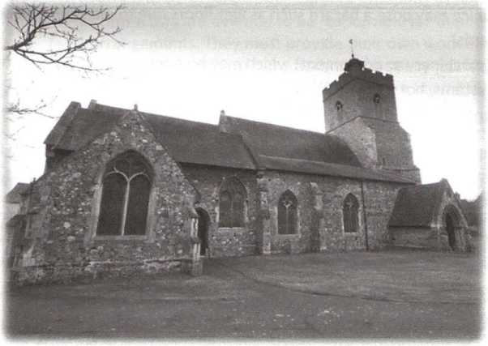St Mary's Church- Wivenhoe

Health & Safety Overview
Version: 1.0
Prepared: 04/02/2023 and reviewed 18th July 2025 by Douglas McCormick

Introduction and Background
St Mary's Church in Wivenhoe has no employees, and as such, does not have the same responsibilities under the Health and Safety at Work Act 1974 (HASAWA) as an employer would have. Therefore, it is only Section 4, 'General duties of persons concerned with premises to persons other than their employees' which applies. Included in this are ensuring the following are as safe as reasonably practicable, and not posing a risk to health.
- The means of access to, egress from, and circulation about the premises (in particular, anything which may pose a hazard such as wet floors due to inclement weather / cleaning, or trip hazards)
- Any plant (machinery or equipment) which may pose a hazard (such as boilers, ladders, electrical systems, hot works etc)
- Any substances which are present (such as cleaning chemicals)
Guidance on heritage buildings recognises that people entering such a building can be reasonably expected to understand that some areas may have uneven surfaces, and they must take responsibility for their own well-being.
Under the Regulatory Reform (Fire Safety) Order 2005, the person(s) in control of a public building must complete a Fire Risk Assessment to determine the people at risk, the hazards arising, and control measures which must be put in place to protect users of the premises.
The Parochial Church Council responsible for ensuring these duties are met in a proportionate way, and that adequate records are kept. Informal records of any issues arising, such as text messages, emails, and minutes from meetings are deemed sufficient.
In addition to legal responsibilities, there are minimum expectations for risk management from the Insurance Company. These expectations extend to the following;
- Control of slips, trips and falls, including regular inspections and associated records of such.
- Control of work at height, which must be suitably assessed for safety, and the associated equipment, such as ladders, which may be used to work at height.
- Fire Safety, including electrical inspections, hot work controls, boiler maintenance, and lightning protection maintenance.
- Security, including protection of valuables such as silverware / brassware, cash, and any metal such as lead affixed to the building.

Arrangements

Assistance
The main source of assistance would be the resources provided by the Insurance Company, including the Risk Advice Line provided.

General Arrangement
Identified Risk | Mitigations
Asbestos | There has been an asbestos survey undertaken.
Bell Ringing | Tower Captain carries out risk assessments and trains bell ringers in accordance with these.
Churchyard | The churchyard is closed. Wivenhoe Town Council (WTC) have responsibility. Concerns arising will be notified to WTC.
Construction Work | Advice to be sought from Insurance Company as required.
Contractors | Contractors are deemed to be responsible for their own health and safety arrangements. They must provide their own work equipment and comply with requirements of our Insurance Company (such as having adequate Public Liability Insurance and following our Insurance Company Hot Works Procedures).
Disability Discrimination Act and Access | Accessible route via the Annexe and an accessible toilet is provided.
Driving (Volunteers) | Drivers will be encouraged to check with their Motor Insurance Company that any driving as part of volunteer activities is covered under their policy.
Electrical Installation | Inspected on a 5-yearly basis.
Events(Church) | Any events, including services, under the control of the PCC will be run with due regard to the safety of the attendees.
Events (Third Party) | Any third-party event organised will be responsible for the safety of any participants / attendees including carrying out their own risk assessments.
Fire Safety | We will carry out a Fire Risk Assessment and follow the precautions identified.
Gas Safety | Gas Appliances will be suitably maintained and inspected annually under the Gas Safe Regulations.
Food Safety | We will follow guidance from the EHO when preparing food at the premises. We will provide basic food safety information for others preparing food away from the premises for events / occasions.
Hazardous Substances | We generally only use domestic cleaning products
Health Management | We will monitor the advice given by Public Health England to identify any local / national issues regarding Public Health, and on occasions where so advised, implement measures to reduce the risk of spread of disease.
Safeguarding | We will follow Diocesan guidance on safeguarding.
Slips Trips and Falls | We will inspect the building regularly and identify any issues which may lead to a slip, trip or fall, and record the dates of any issues arising.
Tower Tours | We will follow the Insurance Company advice if Tower Tours are to be undertaken.
Work at Height | Where possible we will try and avoid the need for work at height. Where this is not practicable, we will ensure that any work is properly planned to identify suitable precautions. We will make sure that these are implemented, including the provision of any training and checks to ensure the safety of any equipment used.

