Fire Risk Assessment and

Audit Report
Church | The Parish Church of St Mary the Virgin
Site Address | St Mary's Church, High Street, Wivenhoe, Essex CO7 9BD
Latitude / Longitude: | 51.855119, 0.959262 (main entrance, North Porch)
Contact Details | Douglas McCormick stmarywivtreasurer@gmail.com
Period of Initial Assessment | April & May 2019 by James Peters
Date of Report | 26/06/2019 (amended and reissued 17/07/2025)
Prepared By | Douglas McCormick

Contents | Page
1. Executive Summary | 2
2. Introduction and Background Information | 3
3. Organisational Chart | 6
4. Health and Safety Arrangements and Premises Audit | 7

Executive Summary

Overview
A fire risk assessment was carried during April/May 2019 to assist St Mary's Church with meeting their legal obligations under the Regulatory Reform (Fire Safety) Order 2005. The purpose of this visit was to review the existing arrangements, inspect the premises (internally and externally), and report back to the PCC / Churchwardens on any issues arising along with recommendations for action.
The results of the audit identify several areas where further action is required, as set out below. Those highlighted in yellow present are considered medium priority, and blue are lower priority. Full details are set out in the body of the report.
Fire Risk Assessments - Compliance Summary
 | # Actions |  | # Actions
1. Management of fire risks | 0 | 7. Fire Detection & Warning | 0
2. Sources of ignition | 0 | 8. Firefighting Equipment | 0
3. Sources of fuel | 0 | 9. Means of Escape | 0
4. Sources of oxygen | 0 | 10. Signs and notices | 0
5. People at risk | 0 | 11. Emergency Lighting | 0
6. Compartmentation | 0 | 12. Prevention of Arson | 0

Priority for Action
To assist in the decision-making process, colour-coded priorities for actions have been assigned;
Unacceptable | A situation that involves a contravention of legislation that could lead to lifechanging/fatal or serious injury and could result in the issuing of a  Prohibition Notice or legal proceedings by the Enforcing Authority. Not  acceptable and requires immediate action.
Substantial | A situation exists that involves contravention of legislation that could lead to serious injury or ill health and is likely to result in the issuing of an Improvement Notice and/or other action, including legal proceedings, by the Enforcing Authority. Not acceptable and requires action to minimise the risk with 7 days..
Moderate | A situation exists where accidents or property damage is possible. Taking action will ensure conformance with health and safety legislation. Action is required within 30 days.
Slight | Where a situation exists that may arguably meet legislative requirements but taking action will result in an improvement in the working environment and/or health and safety arrangements. Action is required within 60 days.
Acceptable | Arrangements are compliant with legislation and best practice.

Introduction
James Peters conducted a review of the existing Fire Risk Assessment and carried out a new Fire Safety Audit in April/May 2019. The purpose of the audit was to establish if/where any gaps in the existing fire safety measures lay and to formalize an action plan to ensure initial compliance and provide a structure for future review in accordance with the Regulatory Reform (Fire Safety) Order 2005.
Compliance with these duties may be routinely checked by the Fire Authority, or as a result of a fire related incident. The Church insurer will also require a suitable and sufficient risk assessment to be undertaken; any failings in fire safety measures may invalidate an insurance claim in the event of a fire.

Fire Safety Management
The overall aim of fire safety management is to identify and implement fire risk control measures with the aim of preventing fires, saving lives and preventing other losses.
Fire Risk Assessment

Identify Hazards

Implement
Controls
Monitor Hazards
/Controls

Review Annually
or on Change
Identify People
at Risk

Limitations of the Assessment
In general, the structural features of the premises and those that were hidden from open view, e.g. ceiling voids, service ducts, etc., may not have been subject to inspection during this fire risk assessment. The 'Responsible Person' has a duty for ensuring that appropriate inspection and maintenance of the structural aspects of the buildings, including the above, is carried out.
It is important to note that the assessment cannot guarantee to cover every aspect of all likely risks. The comments are based on observations and discussions undertaken at the time of a visit.

FRA Inspection and Review
This risk assessment should be available for inspection or validation by any authorised person and should be reviewed and updated;
- Following a significant increase of attendance levels.
- Following any structural or material change to the premises.
- Following any change to the fire precautions in the premises.
- Following a significant near miss or fire incident.
- At recommended intervals of no more than twelve months.

Numbers of People and Type of Activities Undertaken at the Church
The main church activities each week along with average attendance is as follows;
Service | Sunday  0800 | Sunday  1030 | Sunday  Evensong | Wednesday  7 past 7 | Sunday  Taize | Sunday  Holy Ground
Attendance | 11 | 67 | 12 | 8 | 26 | 12

In addition to this, there are various home groups and some ad hoc activities / events during the year. The annual Harvest Service has the highest attendance (121 people).
Additional activities during 2024/25 include;
- Church Quiz Night
- June Market
- Scrufts
- Pre-love Clothing Event
- Café Chill
- Lammas BBQ at the Rectory
- Harvest Lunch
- December Market
Weddings funerals and fundraising events also take place regularly at the church. There was a funeral held at the church in the past, which accommodated approximately 200+ people.
There are no known circumstances where people are permitted to sleep in the building overnight.
For the purposes of the Fire Risk Assessment, a maximum occupancy of 200 people will be considered.
Description of Site Church Building
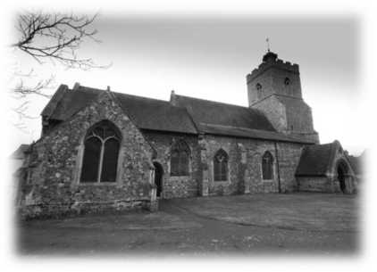
The main building at the site is the Church itself, which is Grade II* Listed¹ lofty stone and brick-built structure with a maximum internal roof height of 11.6 metres.
The roofs are supported on a timber framework, and likely to be a traditional built-up system comprising lathe and plaster, timber boarding, and lead linings overlaid with tiles.
There is an attached Bell Tower at the western elevation which is accessible separately from the churchyard.
Internally, floors are likely to be timber or stone (awaiting inspection). The height of the tower is approximately 17 metres. Access is via stone stairs.
Construction Category: Combustible
Churchyard
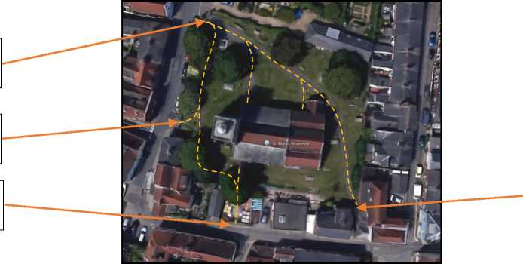
The churchyard covers an area of approximately 2,500 square metres and is bounded by High Street at the western elevation and East Street at the southern elevation. There are houses along the eastern elevation, and Falcon Yard at the northern elevation.
Main entrance from High Street
Secondary entrance from High Street
Entrance from East Street
Entrance via pivot gate from East Street
There are two main thoroughfares for members of the public through the churchyard on hardstanding footpaths, three of which lead to the four church doors. There are six wooden benches, numerous gravestones, various crypts and a war memorial within the churchyard.
As the churchyard is closed, maintenance / repair and groundskeeping is the responsibility of Wivenhoe Town Council.
Heritage ¹ List Entry No: 1225318, County of Essex, District of Colchester, Parish of Wivenhoe.

Organisational Chart

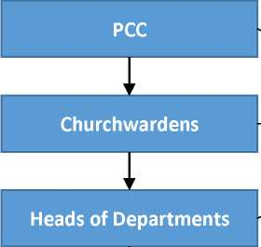

Overall responsibility for health and safety
Support implementation of health and safety
Day to day management of risks / control measures
L

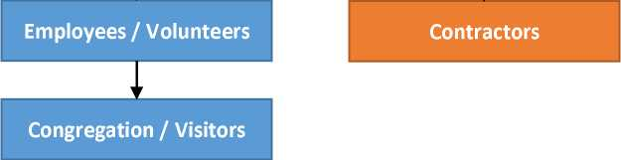
Responsible for personal safety and the safety of others under their care of affected by their actions
Two-way responsibility between contractors and the church for health and safety during works

Suggested map of health and safety responsibilities

Fire Risk Assessment & Audit
Subject |  | Finding | Rating | Action Required | Target Date | Completed
1. Management of Fire Risks
Competent Person Appointed |  | James Peters |  | Monitor. |  | 01/05/2019
Competent Person Qualified |  | FPA Certificate in Fire  Risk Assessment |  | Monitor. |  | 01/05/2019
Floor Plans - General Layout |  | In H&S File |  | Monitor. |  | 01/05/2019
Floor Plans - Fire escape routes |  | In H&S File |  | Monitor. |  | 01/05/2019
Floor Plans - Fire Safety Equipment |  | In H&S File |  | Monitor. |  | 01/05/2019
Floor Plans - Fire Escape Routes |  | In H&S File |  | Monitor. |  | 01/05/2019
Fire Wardens |  | Appointed and present at all services. |  | Monitor. |  | 01/05/2019
2. Sources of Ignition
Electrical Installation | Maintained and in good visual order.  Clear of combustible fuels. |  |  | Monitor. |  | 01/05/2019
Gas Installation / Boilers | Maintained.  In separate rooms. Detection and auto-isolation provided. |  |  | Monitor. |  | 01/05/2019
Main heaters | Hot air blowers - away from fuel sources. Single fixed panel heater in vestry (thermostat controlled) just below mezzanine ceiling level. |  |  | Monitor condition. |  | 01/05/2019

2. Sources of Ignition Continued
Portable heaters | Two provided (organist and vestry). These are clear of combustibles and switched off  and disconnected from the power when not in use. |  | These are switched off and  checked after use. |  | 01/05/2019
Candles - General | Candles are lit during services and in designed holders away from fuels. They may be left burning in specially designed stands after the building has closed. |  | Arrangements are satisfactory. |  | 01/05/2019
Candles - Hand-held: Adults | Candles may be hand-held by congregation members. They are supplied with a drip-guards to adults. |  | Generally satisfactory,  If the opportunity arises, consider changing to tea-lights in glass / ceramic holders. |  | 01/05/2019
Candles - Hand-held: Children | During certain services candles are distributed to children. Younger children are given battery operated devices. Older children may be given lit candles (e.g. Christingle Service) |  | Arrangements are satisfactory.  Additional supervision is provided. Buckets of sand and water are available. |  | 01/05/2019
Hot Works | Contractor controls in place as per Insurance Company requirements. |  | Monitor. |  | 01/05/2019

3. Sources of Fuel
Stored Items - General | Storage on shelves or in cupboards / drawers. |  |  | Monitor to ensure away from ignition sources. |  | 01/05/2019
Fabrics / Linings | Limited to curtains on choir vestry, altar covers etc. |  |  | Monitor. |  | 01/05/2019
Gas - Boiler Room and annexe toilet cupboard | Clear of combustibles. Gas  detection and auto-isolation in place. |  |  | Monitor. |  | 01/05/2019
4. Sources of Oxygen
General Atmosphere | No elevated oxygen levels. |  |  | Normal risk. |  | 01/05/2019
Doors and Windows | Doors are generally closed, but would be open for evacuation.  No fire doors.  Windows are sealed shut. |  |  | Satisfactory. |  | 01/05/2019
5. People at Risk
Employees and Volunteer Staff |  | No issues identified. |  | Monitor. |  | 01/05/2019
Visitors - Able-bodied |  | No issues identified. |  | Monitor. |  | 01/05/2019
Visitors - Mobility Impaired |  | CW's and Sidespersons trained to lookout for people and would assist with evacuation if required. |  | Monitor and provide on-going training for personnel. |  | 01/05/2019
Visitors - Children |  | Generally under adult supervision during activities. |  | Monitor and provide on-going training for personnel. |  | 01/05/2019
Contractors |  | No lone working. Responsible for own safety. Supervised appropriately. |  | Monitor and continue to  review as need arises. |  | 01/05/2019

6. Compartmentation
Plant Rooms | Boiler room is separate  underground  compartment.  Fire stopping provided. |  | Monitor. |  | 01/05/2019
Main Building | No effective compartmentation or fire doors (Grade II  Listed Building) |  | Typical layout for a traditional church building which predates building regulations. Acceptable as risks are mitigated through other  means. |  | 01/05/2019
7. Fire Detection and Warning Systems
Boiler House | CO Detection installed  with auto-isolation of gas supply. |  | Monitor. |  | 01/05/2020
Main Building | Complete fire detection alarm system installed with control panel by annexe exit door. |  | Monitor |  | 01/05/2020
8. Firefighting Equipment and Facilities
Portable Fire Extinguishers | Adequate numbers and types provided to all  areas. |  | Monitor. |  | 01/05/2019
Fire Blanket | Provided at rear. |  | Monitor. |  | 01/05/2019

9. Means of Escape (BS9999 - Occupancy B - Awake and unfamiliar, Fire Growth Rate 1 - Slow. Minimum width per person: 3.6mm)
Main Door - width: 1240mm | Suitable for >300 people |  | Monitor |  | 01/05/2019
Side Door - width: 903mm | Suitable for >250 people |  | Monitor |  | 01/05/2019
Vestry - width: 802mm | Suitable for >200 people |  | Door must always remain unlocked whilst the vestry is in  use. |  | 01/05/2019
Toilets | 3 escape routes fit for purpose |  | Monitor |  | 01/04/2020
Floor surfaces | Even surface in the nave and annexe. Some uneven flooring within the chancel e.g. steps and brasses |  | Monitor |  | 01/04/2020
Belltower - Ringing Chamber | Max occupancy 10 |  | Tower Captain to Monitor |  | 01/04/2020
Belltower - Bell Chamber | Max occupancy: 3 |  | Tower Captain to Monitor |  | 01/04/2020
Boiler room - restrictive ladder | Max occupancy 2 |  | Premises team to Monitor |  | 01/04/2020
10. Signs and Notices
Escape signs | Vestry has no escape signs but this is considered acceptable given the small area, dedicated exit door and limited  use. |  | Monitor |  | 01/04/2020
Assembly Point | In the churchyard. |  | Monitor |  | 01/04/2020

11. Emergency Lighting
Main Building | Installed and  maintained. |  | Monitor. |  | 01/04/2020
Boiler Room | Non-maintained single point system in place. |  | Monitor. |  | 01/05/2019
Vestry | None installed, but unlikely to be required as mainly used in the daytime other than by the Clergy. |  | Current situation is satisfactory |  | 01/05/2019
Belltower | Non-maintained units in the Ringing Chamber and also on the stairs. |  | Monitor. |  | 01/05/2019
12. Prevention of Arson
Security | Gate to main door.  Doors locked shut when not in use. Building clear of combustible storage. Roof alarm installed. |  | Arrangements satisfactory, |  | 01/05/2019

